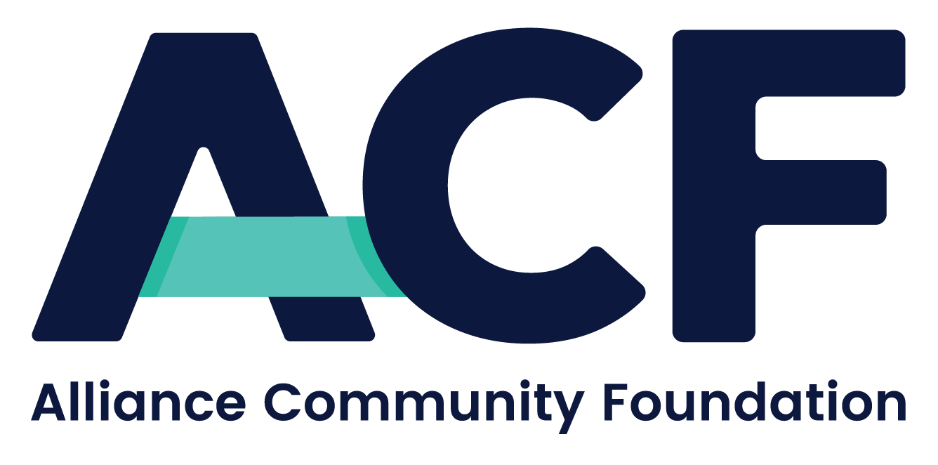

Pooled Income Fund Program

Explanation of How the ACF PIF Operates, the ACF Charitable Remainder Interest Distribution Process, and the ACF PIF Administration Fees

The information below explains how the Alliance Community Foundation Pooled Income Fund program compares to most of the more than 1,300 Pooled Income Funds in existence today. Our aim is to assist professional advisors in explaining to their clients how charitable gifts to the ACF PIF are financially beneficial for their clients, in meeting their philanthropic, financial, tax and estate planning objectives.

How is the ACF PIF program different?

- ACF offers donors “young” pooled income funds, when the investment performance of their soon-to-be old pooled income funds, plus the applicable federal rates, indicate that this would allow donors to enjoy significantly higher income tax charitable deductions.

- ACF allows PIF donors to benefit any number of qualified charitable organizations, after the life of the income beneficiary. ACF requires donors to distribute a minimum of 1% of the charitable remainder interest to ACF for its own unrestricted charitable purposes. The balance of the PIF charitable remainder interest is transferred to a donor advised fund for the donor to advise on how it is to be distributed to qualified public charitable organizations. Most charities on the other hand require 100% of the remaining PIF assets after the income beneficiary’s life.
- The ACF PIF is offered to income beneficiaries of all ages; and for donor families, the PIF can operate for multiple generations. By contrast, most charities require the income beneficiaries to be age 65 or older, and only allow 1 or 2-life PIF Agreements.

- ACF pays out all of the net-realized, short-term capital gains to the income beneficiaries. This allows the PIF investment manager to have greater flexibility and opportunity to potentially engineer more favorable investment returns for the income beneficiaries. By contrast, most charities will not distribute PIF short-term capital gains and instead allocate net gains to the PIF principal.

- ACF is willing to accept PIF contributions of any legally-permitted asset that their gift acceptance policies allow (including privately-held securities and real estate). Most charities accept only cash, or readily marketable, publicly traded securities.

- ACF allows the donor’s trusted investment manager to manage the donor’s PIF contribution, for ACF the PIF Trustee.

- While other charities may have governing provisions in their PIF documents to allow a total return, to our knowledge, very few charities operate a total return producing PIF. This allows ACF to use its “power to adjust” to pay out a portion of the net-realized, post contribution, long-term capital gains. This allows the PIF investment manager to have greater flexibility and opportunity to potentially engineer more favorable investment returns for the income beneficiaries. And, long-term capital gains are currently taxed at lower rates.

Charitable Gifts to ACF

In the case where non-cash PIF gifts are being contemplated, ACF requires donors to contribute charitable gifts to ACF, in advance, equal to the direct costs ACF is expected to incur. Non-cash gifts can be extremely complex and require greater acquisition costs, ownership transfer expenses, and expensive out-of-pocket legal fees for professional services and legal research.

(ACF PIF donors often discover that the primary source of funds needed for the upfront professional services (legal, accounting, appraisal fees, etc.), actually comes from the Federal income tax savings, which flow from the PIF’s generous charitable tax deductions. And, for donors who pay estimated income taxes, the tax savings are enjoyed sooner, because the next estimated tax due has to be recalculated.)

Administration Fees
ACF charges the PIF an annual administration fee. The fee is billed quarterly, based upon the value of the PIF assets at the end of the quarter. A significant portion of these fees represent a charitable gift percentage that enables ACF to fulfill its overall charitable mission.

Note: These fees do not include additional expenses for investment management fees and direct out-of-pocket expenses.

(Importantly, when donors contribute long-term capital assets to the PIF, that are subsequently sold for reinvestment, the PIF pays no capital gains taxes. This means there are more after sale proceeds to invest and this may mean that a greater effective rate of return can be quantified for the income beneficiary. Why? Because no capital gains tax is paid, there is more money to invest in the PIF.

Additionally, the income tax savings, generated by the Federal income tax charitable deduction, may offset the PIF taxable income for up to 6 years, depending on the income beneficiary’s circumstances.
Finally, ACF PIF income beneficiaries potentially have the opportunity to receive legally-permissible net short-term capital gain income and net long-term capital gain income from the investments managed by their trusted advisors.)
PIF Planning Opportunities
The PIF can create significant income tax savings, by generating substantial charitable deductions (not affected by the Alternative Minimum Tax). The tax deduction can offset post-transaction taxable income or for offset other ordinary taxable income. The PIF deduction may be engineered to average down the tax cost of nearly any liquidity event. It can create a virtual capital gains type of taxation on an ordinary income tax transaction, if half of the ordinary income event is sheltered by the deduction. Imagine being able to create a charitable deduction without forgoing the income earned from the gift that was donated to the PIF.
Notable Features and Benefits of the PIF
- Receive payments with the potential to increase with inflation, including net realized short-term gains
- Transfer qualified debt-encumbered assets to the trust
- UBTI subject to trust tax rates—not CRT 100% rate
- Involve multiple family members as concurrent or consecutive income beneficiaries
- No minimum or maximum payout rate
- No 10% minimum charitable remainder interest requirement
- Enjoy lifetime income that include favorable long-term capital gains tax rates (see the “Total Return” PIF section above)
- Receive deductions significantly higher than a comparable Charitable Remainder Unitrust/Annuity Trust or Gift Annuity
To contribute to the Alliance Community Foundation Pooled Income Fund, please follow these instructions:

- Please request the ACF PIF Disclosure Statement and PIF Donor-Beneficiary-Remainderman Form and please review these documents with your legal and financial advisors.

- Contact the ACF Planned Giving Office regarding the type of gift you intend to contribute. Email: drice@alliancecommunityfoundation.org or call Dan Rice at (772) 365-1030.

- If you wish to proceed on making a gift to the ACF PIF, please complete and return the ACF PIF Donor-Beneficiary-Remainderman Form. Afterwards, we will send you the PIF Agreements, with the relevant forms and instructions that you will need, in order for you to make a completed gift to the PIF.

Dan Rice
President, CEO
Office | Mobile (772) 365-1030

ALLIANCE COMMUNITY FOUNDATION
AllianceCommunityFoundation.org

